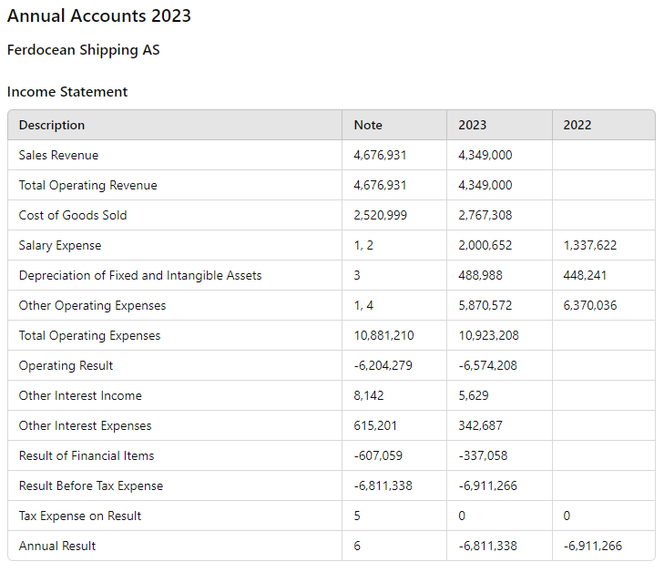
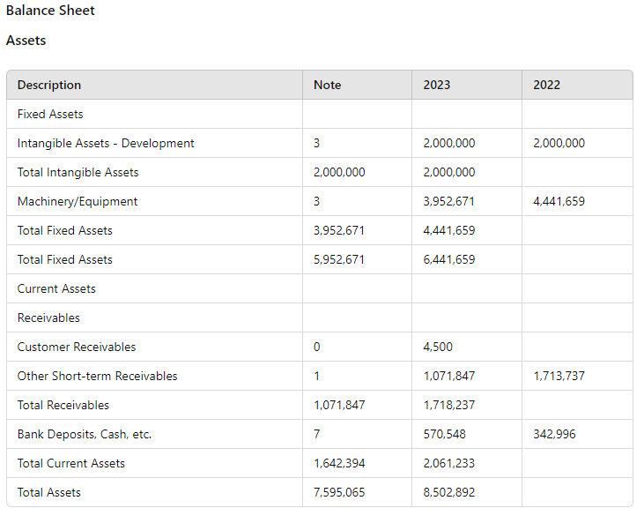
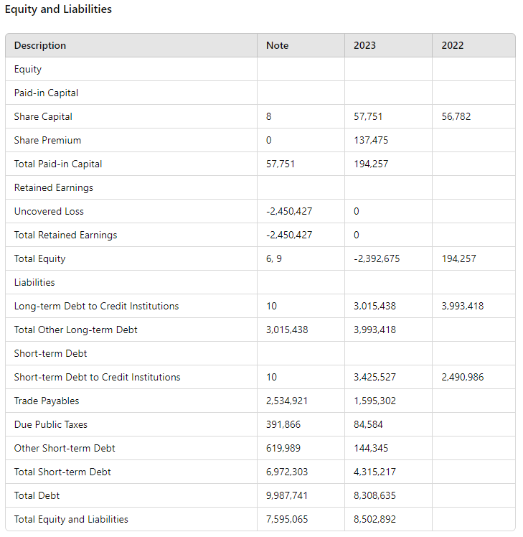
Stavanger, 25.06.2024 Board of Directors of Ferdocean Shipping AS
- Per Kristian Nagell, Chairman
- Musa Adnin, Board Member
- Tore Ausland, Board Member
Accounting Principles
The annual accounts are prepared in accordance with the Accounting Act and NRS 8 - Good accounting practice for small enterprises.
Taxation The tax expense in the income statement includes both payable tax for the period and changes in deferred tax. Deferred tax is calculated at 22% based on the temporary differences that exist between accounting and tax values, as well as the tax loss carryforward at the end of the fiscal year. Tax-increasing and tax-reducing temporary differences that reverse or can be reversed in the same period are offset and netted.
Classification and Valuation of Fixed Assets Fixed assets include assets intended for long-term ownership and use. Fixed assets are valued at acquisition cost. Depreciation is calculated over the economic life of the asset. Fixed assets are written down to their recoverable amount if a decline in value is expected not to be temporary. The recoverable amount is the higher of net sales value and value in use. Value in use is the present value of future cash flows related to the asset. Impairment is reversed when the basis for the impairment is no longer present.
Classification and Valuation of Current Assets Current assets and short-term liabilities normally include items that are due for payment within one year after the balance sheet date, as well as items related to the operating cycle. Current assets are valued at the lower of acquisition cost and fair value.
Receivables Customer receivables and other receivables are recorded at face value less provisions for expected losses. Provisions for losses are made based on an individual assessment of each receivable.
Notes to the Financial Statements
Note 1: Public Grants
- The company received approval for a project in 2020 for the period 2020 to 2022.
- SkatteFUNN for 2020 of NOK 101,181 was included in 2021.
- SkatteFUNN for 2021 of NOK 613,092 is included in 2021 and included in other short-term receivables at the end of the year.
- The company received NOK 1,251,990 more in final tax settlement in 2022 than accounted for in last year's financial statements; NOK 225,358 was recorded as a reduction of salary expenses and NOK 1,026,382 as a reduction of other operating expenses.
- SkatteFUNN for 2022 of NOK 755,329 is included in 2022 and included in other short-term receivables at the end of the year.
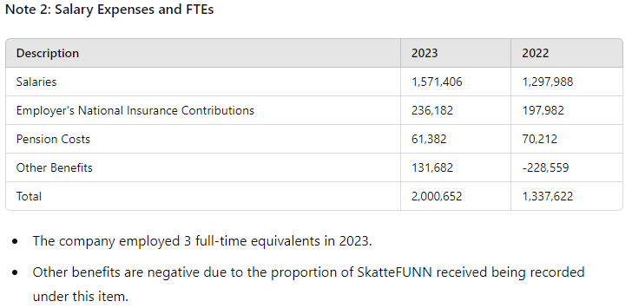
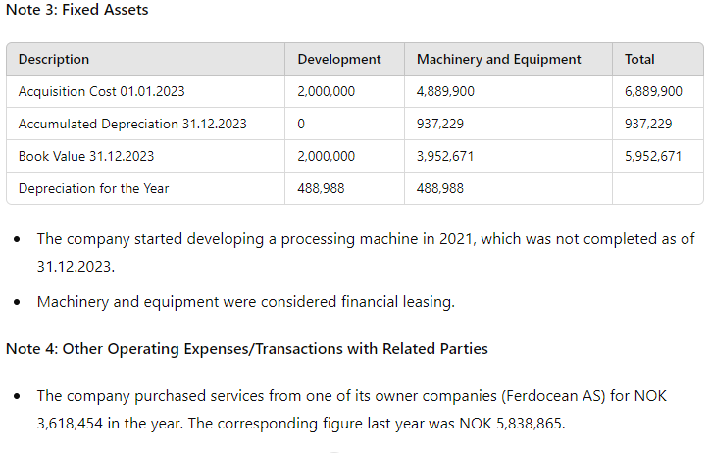
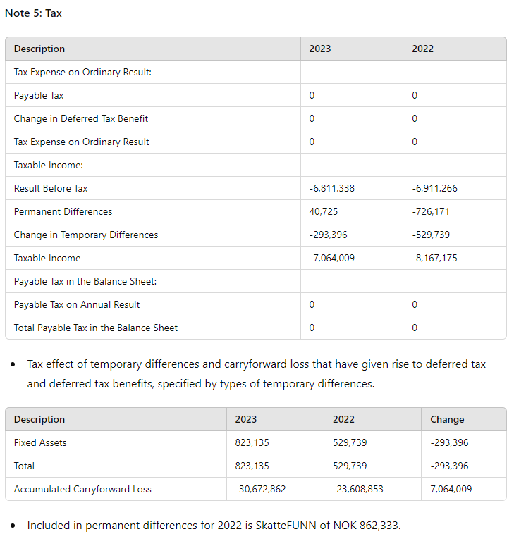
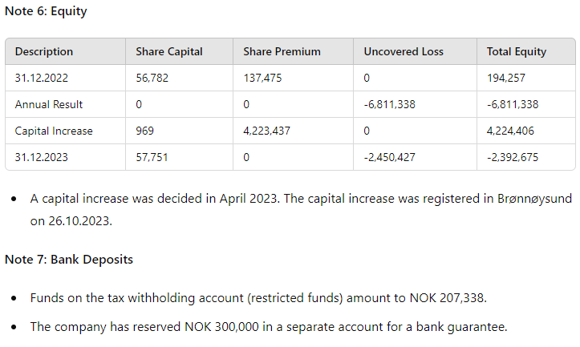
Note 8: Shareholders
- The share capital in Ferdocean Shipping AS as of 31.12 consists of: | Description | Number | Nominal Value | Book Value | |-------------|--------|---------------|------------| | Ordinary Shares | 180,140 | 0.32 | 57,790 | | Total | 180,140 | 57,790 |
- Ownership Structure: | Shareholders | Ordinary | Ownership % | Voting % | |--------------|----------|-------------|----------| | Ferdocean AS | 64,980 | 36.07 | 36.07 | | Gunnar Nordbø | 33,760 | 18.74 | 18.74 | | Shield International Ltd | 31,040 | 17.23 | 17.23 | | Ma'Mor Holdings SDN BHD | 29,724 | 16.50 | 16.50 | | Wilmar Gruppen AS | 12,000 | 6.66 | 6.66 | | Morcidea AS | 3,961 | 2.20 | 2.20 | | TE Invest AS | 2,695 | 1.50 | 1.50 | | Quality Group Invest AS | 520 | 0.29 | 0.29 | | Proco Professional Consultants AS | 500 | 0.28 | 0.28 | | Haugjegla Invest AS | 320 | 0.18 | 0.18 | | Mosby Holding | 320 | 0.18 | 0.18 | | Superiore Capital AS | 320 | 0.18 | 0.18 | | Total Shares | 180,140 | 100.00 | 100.00 |
Note 9: Going Concern Ferdocean Shipping AS collaborated with several financial advisors for capital expansion and facilitation nationally and internationally throughout the period. Due to liquidity concerns, a share issue round was conducted among existing shareholders, where fresh capital was injected into the company (approved and registered in the Brønnøysund Register). The effort to recapitalize the company to achieve stronger operating capital and investment capital for several processing plants has been and is of the highest priority. The company was in dialogue with several major industrial stakeholders (both nationally and internationally), aiming to secure an issue in the company of between NOK 100 million and NOK 150 million. This did not materialize during the year. The board has also received approval from an extraordinary General Assembly to raise NOK 6 million convertible loan from existing shareholders.
Ferdocean Shipping AS carried out a successful operation with Equinor on the Oseberg Sør field in February/March 2023, resulting in operating revenues for the company. In addition, further engagement was entered into for Equinor on the same field in May 2023. This task was, however, postponed indefinitely, but contractual compensation from Equinor was received. There was further interest from oil companies as well as drilling contractors for the company's concept throughout the year, but further contracts were not entered into due to lack of capital and delayed start-up of various drilling campaigns. Based on the above, the company believes that it can ensure a sound basis for continued operation and strengthening of the company's equity through the ongoing share issue. Shareholders have committed to providing financial assistance to cover the company's ongoing financial needs throughout the year should this be necessary.
The above measures, in the board's opinion, reduce the uncertainty about continued operations, and the board thus submits the annual accounts on this basis.

